Pomodoro Technique CSE 110 Plan

1. The following sections in “The Pomodoro Technique” PDF are relevant for this class as they cover the “basics” of this technique:
   1. Material and Method
   2. Objective I
   3. Objective II
   4. Objective III
      1. We’re not too sure on how likely it is to add estimations to the application before the end of the quarter
2. Materials needed:
   1. A Pomodoro timer
      1. 1 Pomodoro = 25 minutes
      2. Rule: A Pomodoro is indivisible, unlike Trump
         1. This means things like half a Pomodoro don’t exist
      3. Void interrupted Pomodoros
      4. A completed Pomodoro is represented by an X on the To Do Today sheet
      5. 5 minute break after every Pomodoro
         1. 25-30 minute break every 4 Pomodoros
      6. You can’t do anything other than the task at hand during a Pomodoro
   2. To Do Today sheet
      1. Contains a list of things to do today in order of priority
      2. Contains a section labeled “Unplanned & Urgent Activities”
         1. You only add tasks to this section if a distracting task comes up that can’t be avoided
         2. The rest of the distracting/new tasks should be added to the Activity Inventory sheet
   3. Activity Inventory sheet
      1. Stores the various **NEW** activities that come up during the day
   4. Records sheet
      1. This is most likely the thing we want to visualize on our application
      2. Contains all the tasks completed at the end of the day
3. Interruptions
   1. Internal interruptions
      1. Mark all potential interruptions coming up with an apostrophe (’)
      2. Three different decisions for internal interruptions
         1. If you can’t avoid it, add it to the “Unplanned & Urgent” section in the To Do Today sheet
            1. Note: you must replace all interrupted Pomodoros with an apostrophe
         2. If you can avoid it for now, add it to the Activity Inventory sheet (with a deadline if you want)
         3. Go tryhard to finish the task (still have to mark the distraction, though
      3. After every Pomodoro, you can make a decision on how to deal with the newly added activities in the Activity Inventory sheet
         1. Dedicate a Pomodoro on 1 (or more if some take less than 25 minutes to do) of these activities
         2. Reschedule them to do in place of other activities
   2. External interruptions (I have no idea how to deal with this in the application)
      1. Protect the Pomodoro
         1. Inform, Negotiate, Call Back Strategy
         2. Enables you to control the external interruption by rescheduling them to later Pomodoros depending on how urgent they are
         3. Causes people to realize that you are truly busy and shouldn’t be interrupted
      2. External interruptions are represented by a dash (-)
      3. The three different ways to deal with these interruptions are the same as internal interruptions (copied from above):
         1. If you can’t avoid it, add it to the “Unplanned & Urgent” section in the To Do Today sheet
            1. Note: you must replace all interrupted Pomodoros with a dash
         2. If you can avoid it for now, add it to the Activity Inventory sheet (with a deadline if you want)
         3. Go tryhard to finish the task (still have to mark the distraction, though
   3. Below are what the three sheets should look like given this current information:

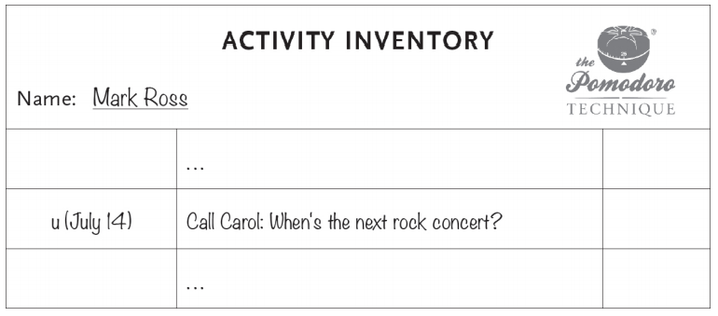

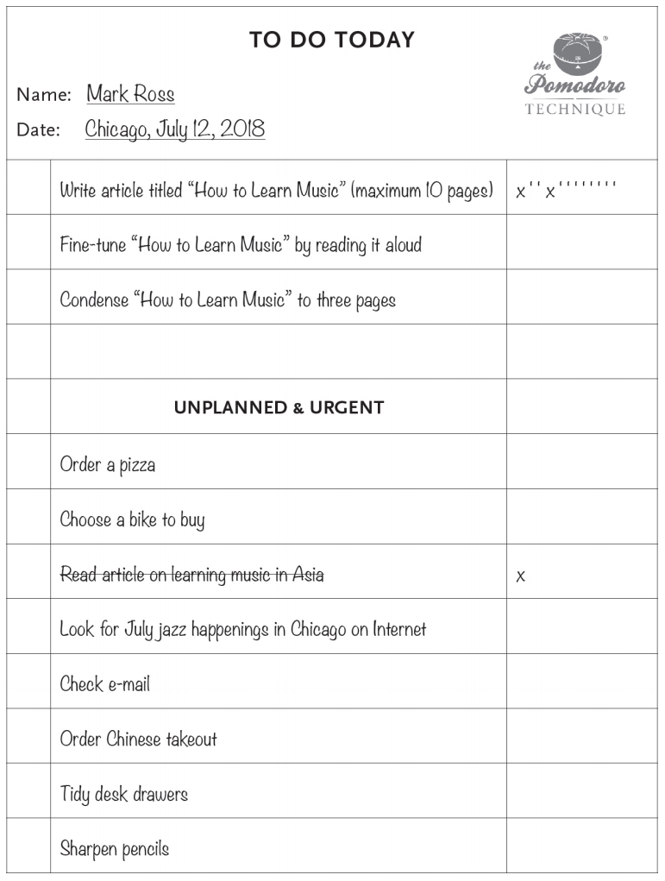

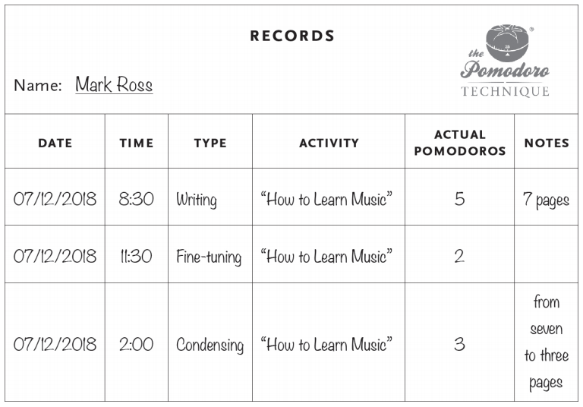

1. Estimating the efforts for the activities (tentative, we found this very hard to incorporate into our design)
   1. At the start of each day, estimate the amount of Pomodorors each activity will take in the Activity Inventory sheet
   2. Rules:
      1. Something that takes more than 5-7 Pomodoros should be broken down
      2. (mentioned a few times above) Activities that take less than 1 Pomodoro should be grouped together
   3. Start picking out tasks from the Activity Inventory sheet and adding them to the To Do Today sheet
      1. For each task in the To Do Today sheet, add the number of checkboxes equal to the estimated number of Pomodoros
      2. Do what you did above (add X, (’), and (-) depending on what happens), except this time the X’s should go in those checkboxes [X]
         1. Cross out activities that are completed (should either have all checkboxes filled out or some)
         2. Continue tasks even if you fill all checkboxes, adding more X’s outside of the checkboxes (put those X’s in circles)
   4. At the end of the day, update the Records sheet like usual, except this time, add the estimated number of Pomodoros, real number of Pomodoros, and difference in estimation and real Pomodoros
   5. Below are what the three sheets should look like after adding the estimation mechanic:

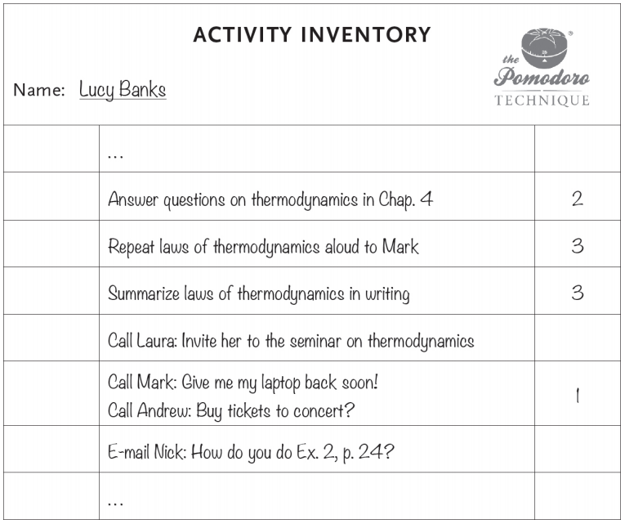

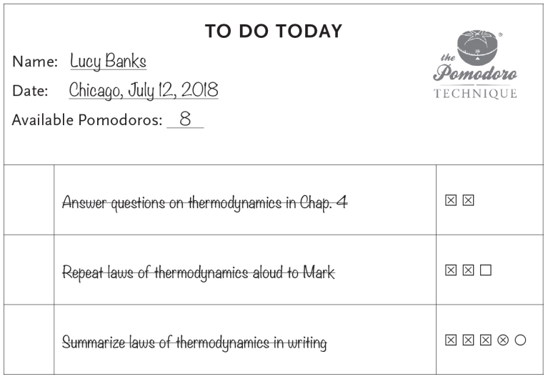

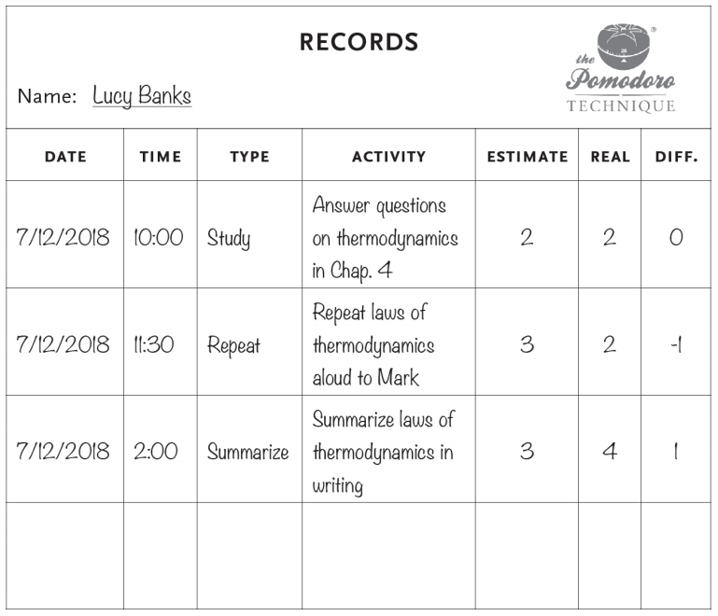

* Ideas for the project based on the trimmed Pomo110 App presentation:
  + One thing we noticed on these slides is that it says “digital Pomodoro modifications.” Thus, we thought of the following things below:
    - Skeuomorphic design
      * We deem this as something that’s not practical for the purposes of this class and probably even distracting for the user
    - Muting of notifications
      * From what we see, since this is a web application, it’s only possible to mute the application itself and not notifications that come from applications outside of our Pomodoro application
    - Visualize recorded/logged activity
      * This is practical and pretty much the goal of the web application
      * It should focus on the Records sheet
    - A way to interact with the application without inherently opening it up
      * This is probably the least practical thing to do, especially for a web application
        + Voice recognition might be possible, but we need an entire algorithm for it
        + Some of the things listed in the slides require server architecture, which might not be possible in the scope of this class
        + Keyboard commands might also be possible, but you need macros to prevent interacting with the application
      * There are a few things about the Pomodoro Technique that make it harder to implement:
        + Pomodoro timer shouldn’t even be touched outside of starting it
        + Adding your activities inherently can’t be done without interaction except for in the case of voice recognition
  + Potential use cases
* Ideas for the project
  + The ideas below are based on two reasonings:
    - make the application as far from distracting as possible
    - Reduce the amount of times the user has to click on the website as much as possible
    - Powell emphasized the constraints of 6 weeks and availability for a reason
      * Play it as safe as possible and minimize the number of features to implement
  + Still planning the features